Name: Sylvia Le

Course: COM219

**HOMEWORK 1**

**Question 2:** 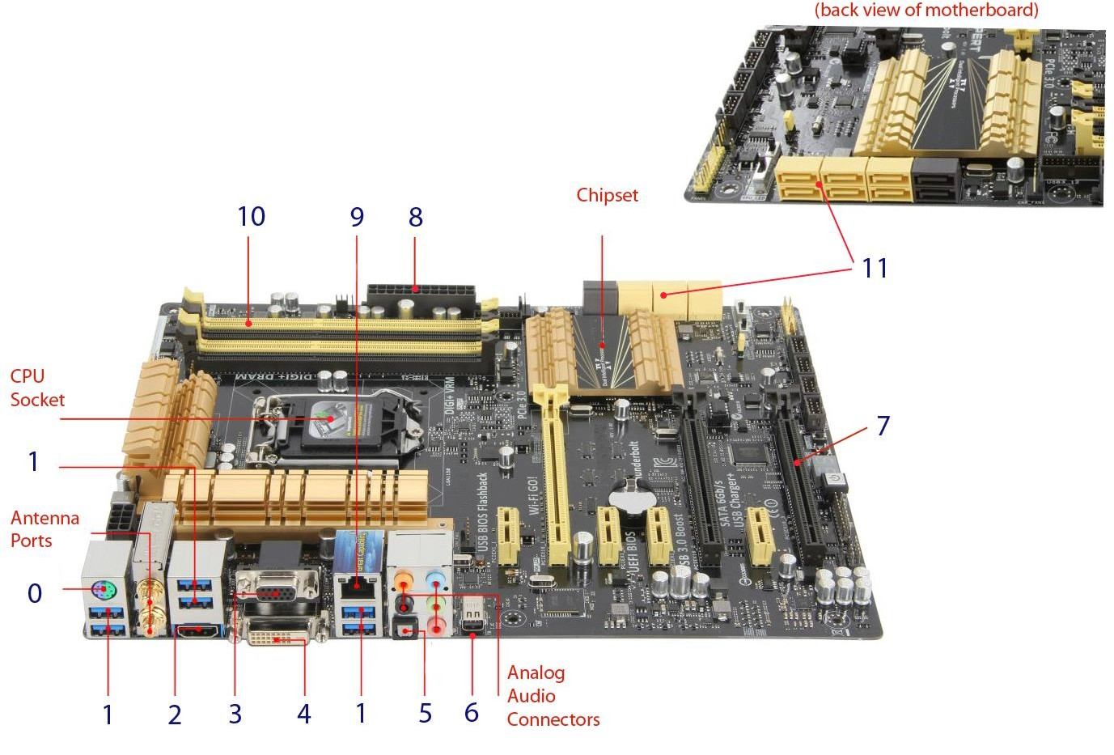

|  |  |  |
| --- | --- | --- |
| **Connector number** | **Name of connector** | **Function** |
| 0 | PS/2 mouse/keyboard port | 6-pin mini DIN connector used for connecting keyboard and mice to PC |
| 1 | USB 3.0 ports | Use for transferring data, with transfer time theoretically 10 times the predecessor USB 2.0 |
| 2 | HDMI Port | 19 pins connector used to transmit digital video and audio signals between devices.  Support standard-definition, high-definition and Ultra HD video signals |
| 3 | VGA Port | 15 pins connector used for computer video output |
| 4 | DVI-D Port | A video display interface is used to connect a video source (video display controller) to a display device (computer monitor) |
| 5 | DTS Support | Support DTS sound system |
| 6 | Thunderbolt port | Hardware interface that connects peripherals to computers. Support high speed and high resolution media display |
| 7 | GPU | Specialized circuit used for rendering graphics on monitor |
| 8 | Power cable main connector | Connect to the power cord, that temporarily connect the PC to electricity supply |
| 9 | Modem Ethernet | Connect to Ethernet cables, that connects wired network |
| 10 | DDR3 Support | A type of synchronous dynamic random-access memory (SDRAM). Able to transfer data at twice the rate, enabling higher bandwidth or peak data rates, compare to its predecessor |
| 11 | SATA 6Gb/s Ports | Interface that connect motherboard to mass storage devices |

**Question 5:**

e.g. Motherboard, power supply, CPU, RAM, chipset, disk, sound card, graphics, card, network

|  |  |  |
| --- | --- | --- |
| **Chip/Device** | **Component Class** | **Approximate Price** |
| ASUS WS C422 SAGE/10G LGA2066 ECC DDR4 M.2 U | Motherboard | $650 |
| AMD Radeon Pro WX 9100 - 4096 Stream Processors, 16GB vRAM | Graphic card | $2000 |
| Intel Core i7 i7-7700K - Quad Core, 4.2GHz | CPU | $370 - $450 |
| MSI MEG X570 AMD SATA 6Gb/ USB 3.2 | Motherboard | $360 - $530 |
| Intel Core i9-7980XE X-Series 2.6 GHz 18-Core LGA 2066 | CPU | $1980 - $2000 |
| Cisco 32GB DDR4-2666-MHZ RDIMM PC4-21300 DUAL | RAM | $200 |
| NVIDIA QUADRO RTX 8000 | Graphic card | $5500 |
| AMD Ryzen Threadripper 1920X 12-Cores, Socket sTR4, 3.5GHz | CPU | $500 - $650 |
| Intel 10PK OPTANE 800P SERIES INT 120GB | SSD | $200 |
| Intel C246, 14 USB Ports, 24 PCI Express Lanes | Chipset | (skip) |
| Corsair CX Series CX450M 450 Watt ATX | Power supply | $80 |
| Kingston 16GB DDR4, 2133MHz DIMM - KVR21R15D4/16 | RAM | $70 - $80 |
| AMD Phenom II X2 560 | CPU | $65 (peak: $120) |
| NVIDIA Tesla K80 24GB GDDR5 CUDA Cores | Graphic card | $1700 |
| Creative Sound Blaster Z Series ZXR | Sound card | $350 |
| Seagate 1TB SATA 7.2K RPM 6GBPS 2.5IN | HDD | $150 |